The GiveBIG

Campaign Guide

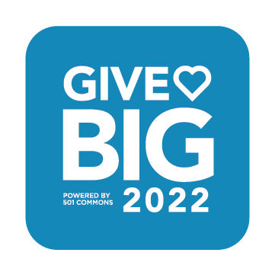

# Directions for Using this Document

**This document provides recommendations and a sample fundraising and communications plan for a GiveBIG campaign**. You can use this document as a template, replacing the sample emails/message, social media posts, and fundraising strategies with your own copy and fundraising strategies to produce a final document that reflects your organization’s GiveBIG campaign.

Be sure your organization considers each recommended strategy, even if you don’t use them this year. Use social media and have fun sharing stories about your work’s impact. Try out peer-to-peer fundraising pages or matching funds! Even a small matching fund and one individual fundraising page by an active supporter can increase the donations you receive. Pay special attention to getting lists of potential donors (with emails) in place. Remember, 100% of the people *you do not ask* don’t give!

**Fundraising is the gentle art of teaching the joy of giving. – *Hank Rosso***

**Table of Contents**

To update the table of contents:

right-click on the table of contents, choose “update field” and then choose “update entire table.”

Directions for Using this Document 1

Getting Started 3

About GiveBIG and Washington Gives 3

Key Dates 4

Resources 4

I. Campaign Checklist 5

II. Setting Up Your Organization Page 6

Organization Page 7

General Settings 12

Checkout 12

III. Develop your Fundraising Plan 14

Match 14

Peer-to-Peer Fundraising 16

Donor-Advised Funds and Individual Retirement Account Contributions 17

IV. Communication Plan 18

Audience 18

Message 18

Methods 22

VI. Stewardship Plan – Thanking Donors 23

Social Media Thank You 24

Mailed Thank You 24

Thank You Calls 24

Next Steps 25

# Getting Started

## About GiveBIG and Washington Gives

### What is GiveBIG? What is Washington Gives?

GiveBIG is a statewide fundraising campaign where individuals and organizations come together across Washington to invest in our communities. GiveBIG is hosted on the Washington Gives online giving platform ([www.wagives.org](http://www.wagives.org)) that helps individuals, groups, and businesses discover and donate to nonprofits headquartered or serving Washington State all year long.

### When is GiveBIG?

This year’s GiveBIG kicks off on April 19 with early giving and culminates on May 3 and 4! The official campaign starts on April 19, but donors can donate on the Washington Gives platform all year long. Throughout the year, you can also run your own campaigns, including peer-to-peer fundraising pages for individuals and teams.

### Who runs GiveBIG and Washington Gives?

GiveBIG is powered by 501 Commons, with the technology of Mightycause and the marketing and media support of Encore Media Group. We are a 501c3 tax-exempt charitable organization that provides 30+ services to amplify the strengths of nonprofits. For more than 30 years, 501 Commons has offered innovative solutions and expertise, working in partnership with the nonprofit community. When GiveBIG needed a new host, we welcomed the opportunity to support the nonprofit sector and the communities we serve. Besides running the GiveBIG campaign and Washington Gives platform, we support nonprofits with low-cost and free services, including finance, HR, technology, data solutions, board development, strategic planning, leadership development, and free information and referral! [Learn more about 501 Commons](https://www.501commons.org/).

### Why do donors participate?

For donors, GiveBIG is an opportunity to be part of a statewide movement of generosity, where we come together as a region to invest in our community. They can easily give to all the causes they already support all in one place and find new nonprofits to give to! Washington Gives makes it easy and fun to discover and donate to many causes.

Donors can also use the Washington Gives platform to help the organizations they care about raise needed funds and awareness. It’s simple to share organization pages with their family, friends, and colleagues, or take it a step further and set up their own fundraising page for a specific organization.

### Why should nonprofits participate?

For nonprofits, GiveBIG is a collaborative campaign that spikes awareness of charitable giving across the state. Together, we can deepen engagement with our current donors, reach new supporters, and rally businesses and media to give to a variety of local causes. The training and resources provided by 501 Commons and our partners for GiveBIG help organizations build skills and knowledge of fundraising and communication strategies.

The Washington Gives platform also provides year-round low-cost online fundraising technology. Washington Gives offers nonprofits of all sizes monthly giving, peer-to-peer fundraising pages, and highly customizable organization pages that nonprofits can use for tracking campaign goals and matches during GiveBIG, GivingTuesday, or whenever they want! Your registration and participation fee covers year-round use of the Washington Gives platform. [Learn more about eligibility and fees](https://www.wagives.org/giving-events/givebig22/eligibility).

## Key Dates

**April 15:** Last day to register for GiveBIG and Washington Gives 2022

**April 19:** GiveBIG kicks off with early giving

**May 3 - 4:** GiveBIG culminates with the 48-hr giving event

**May 6:** Last day for GiveBIG donations

**You can edit your page and goals at any time**. You can also add or change your match at any time!

## Resources

Be sure to save time and enhance your results by using the resources 501 Commons has provided.

* [Tools for Nonprofits](https://www.wagives.org/giving-events/givebig22/nptoolkit): for all resources, previous copies of the Fundraising Accelerator newsletter, graphics and logos, and upcoming and recorded training.
* [Tools for Fundraisers:](https://www.wagives.org/giving-events/givebig22/frtoolkit) for resources for individuals and groups supporting nonprofit efforts through peer-to-peer fundraising.
* The [Washington Gives Support Team](https://www.wagives.org/giving-events/givebig22/contact) is standing by to assist nonprofits and donors!

# Campaign Checklist

This checklist identifies the primary activities that comprise a GiveBIG campaign. All organizations should complete the Essentials column activities to attract new and returning donors on the Washington Gives website. Organizations with additional time and capacity should also complete many of the *Next Level* column activities.

|  |  |  |  |
| --- | --- | --- | --- |
| **Activity** | **Date** | **Essential** | **Next Level** |
| **Participation Requirements** | | | |
| Complete [registration](https://www.wagives.org/giving-events/givebig22/registration) for 2022. | April 15 | **√** |  |
| Complete your organization profile page.  Your page can be edited later, but you want to be ready for GiveBIG when early giving begins. | April 19 | **√** |  |
| **Evaluation & Goal Setting** | | | |
| Review prior year(s) GiveBIG results or previous fundraising campaigns. | Early March | **√** |  |
| Set goals and metrics for 2022. We recommend setting a goal for total donations or donors. | March | **√** |  |
| Review your 2022 results | After May 6 |  | **√** |
| Plan for 2023 | Fall 2022 |  | **√** |
| **Peer-to-Peer Fundraising Pages** | | | |
| Identify supporters to invite to be volunteer fundraisers. | Late March | **√** |  |
| Ask supporter(s) to create a fundraising page by April 19 to help kick off your campaign. They can make a page anytime, but you want them to be ready for the campaign to kick off. | Early April | **√** |  |
| Send fundraiser(s) the Toolkit for Fundraisers or create a fundraiser template on the Washington Gives platform to send them. | Early April | **√** |  |
| Check-in & encourage fundraiser(s) throughout the event. | Late April | **√** |  |
| **Matching Funds** | | | |
| Talk with your board about participating in a matching fund | February - March | **√** |  |
| Identify other supporters to solicit for matching funds outside of your board | February - March |  | **√** |
| Solicit donors for matching funds | February - April |  | **√** |
| **Campaign Communications** | | | |
| Assemble lists of donors and & potential donors; research missing emails | March - April | **√** |  |
| Set up email marketing program (such as Mailchimp or MailerLite) | February - April |  | **√** |
| Create a communications plan and timeline | March | **√** |  |
| If none, set up social at least one social channel, particularly Facebook | Early March | **√** |  |
| Segment your audience (at a minimum, current donors & potential donors) for customized communications. | Early April | **√** |  |
| Prepare emails, print copy, graphics, and social channels | March - April | **√** |  |
| Execute content for social channels | April - May | **√** |  |
| **Events** | | | |
| Determine GiveBIG tie-ins to current events: Could you recruit or announce matching fund donors or encourage fundraisers? | Early March | **√** |  |
| Plan informal events to connect with donors or potential donors (online or in-person) during or after your GiveBIG campaign. Don’t forget to list it on the Washington Gives website once the event functionality is live! | April - May |  | **√** |
| **Stewardship** | | | |
| Determine how to thank donors. If you have many donors, you may have to decide the level of thank you they get, whether it be an email, handwritten card, call, or something more. | Early April | **√** |  |
| Create thank you letters, postcards, notes, or scripts for calls. | Early April | **√** |  |
| Thank your donors within 24-48 hours after they make their gift. | April 19 - May 6 | **√** |  |
| Thank your fundraiser(s) when they sign up and after the campaign ends. | Early May | **√** |  |
| Remind donors about employer matching gifts | Late June |  | **√** |
| Remind DAF/IRA donors to complete DAF distribution | May |  | **√** |

# Setting Up Your Organization Page

The Washington Gives platform helps donors discover nonprofits by searching by name, keyword, mission category, demographics, and location. Donors will see a tile with your organization’s logo, which they can click to go to your *Organization Page*. An engaging and impactful organization page is critical to sharing your story with new and returning supporters. **You do not need to create a *Campaign* to participate in GiveBIG. Your *Organization Page* is all you need**. *Campaigns* are an option to create specific peer-to-peer fundraisers that will appear on your organization’s page.

## Organization Page

Below are in-depth recommendations for creating your organization page. **You can edit your page at any time!** To learn more about navigating your account as a whole, review the [Your Organization Dashboard](https://support.mightycause.com/hc/en-us/articles/360013787071-Your-Organization-Dashboard) help article from Mightycause.

### How to access your organization page

Log in to your account (www.wagives.org/login). When you log in, you will be on the *Overview* page. The *Overview* page includes your ***To-Do* list with the steps you need to be ready for GiveBIG**. Click on the *To-do* list to see a complete list of what you need to do, and click on the links to be taken to the correct spot on the website to complete the required steps.

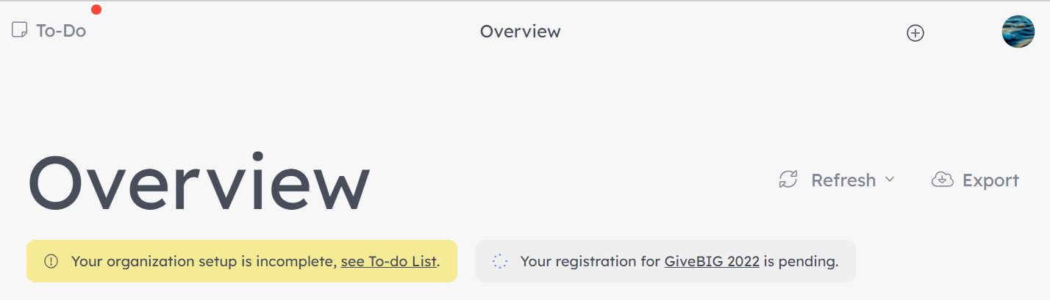

Click on Organization Page to edit or preview your page on the left side.

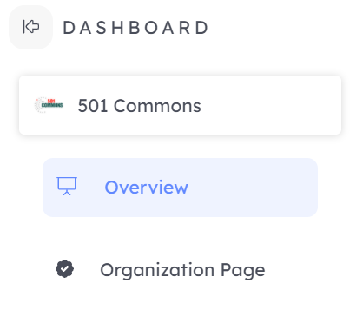

From here, you can edit your page in real-time. When you save, your changes will be live automatically.

### Banner image

The *Banner Image* is one of the first things donors will see when visiting your page! It should give them a sense of what you do and why. Smiling faces and people engaged in an activity are most impactful. This image should be a 3:1 ratio.

### Logo

Logos for your organization page must be a 1:1 ratio. If you have a horizontal logo, you may need to put it on a square background. Make sure your logo isn’t blurry or cut off, as this is the first thing the visitors to the Washington Gives website will see.

### Title/display name

The title is your public display name. This can be your legal name or “doing business as” name. We recommend whatever name you most commonly refer to your organization as.

### Fundraising stats

You can adjust what fundraising stats show publically on your page at any time. If you do not want this section displayed, select *Hide section.*

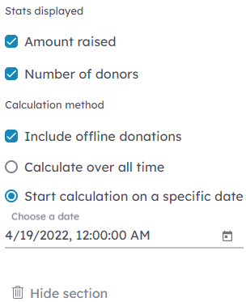If you do want to show stats, you can choose to show one or both of the following:

* *Amount raised*
* *Number of donors*

You can now enter donations received outside the Washington Gives platform. If you want to include these donations in your public total, select Include offline donations. **Note that offline donations do not count towards your participation fee or donation processing fees.**

To determine which donations or donors are shown on your page, you can either select:

* ***Calculate over all time*:** To show all donations and donors who have ever given to your organization through Washington Gives or Mightycause.
* ***Start calculation on a specific date*:**To show donations after a certain date and time. To set your organization’s stats for GiveBIG 2022, we recommend you select this option and set the date to when early giving starts, April 19, 2022, at 12:01 AM. If you get a gift in early that you want to count towards your GiveBIG total, move the date back to when you received your earliest gift. Please note that only gifts that come in between April 19 and May 6 count towards your participation fee, so moving the calculation will not impact your fee.

### Goal

Your public page only shows a goal for funds raised, but we encourage you to consider and track other goals such as number of donors, monthly donors, or new donors. Communicating your progress to meeting your goals via email or social media encourages your supporters to help you succeed!

#### Setting your goal

Remember, if you aim for nothing, you hit it every time! If your organization participated in GiveBIG 2021, reviewing last year’s campaign data will give you a treasure trove of information you can use to make this year’s campaign more successful.

Quickly review your 2021 stats from your *Overview*. Set the time period to *Last 12 months.* 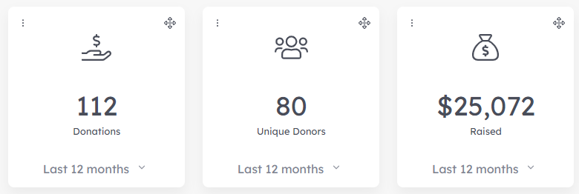

Go to *Reports*, then *Donations*, and select *Campaign type* for a more detailed report. Then select *View by Giving Event* and set the *Campaign name* to *GiveBIG Washington 2021*.

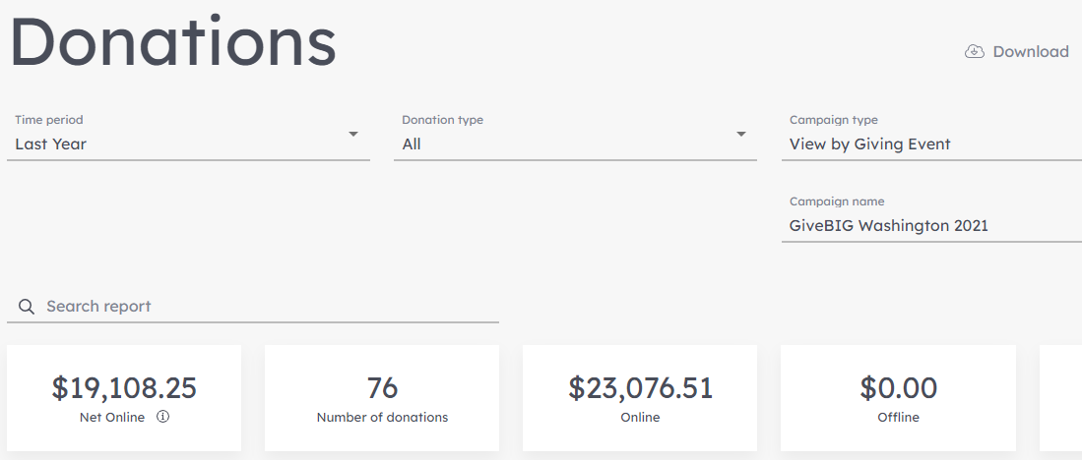

#### Updating your goal on the platform

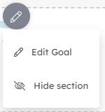

You can update your goal at any time or choose to hide it by selecting *Hide section.* If you have a match, it will not count towards your displayed goal unless you adjust it to do so under Fundraising Tools and Matching Grants.

If you meet or exceed your goal, you can increase your goal. Donors are most likely to give when you are close to your goal. It creates a sense of urgency and motivates donors to make their gift to help you get over the finish line. Make sure to plan why you are extending your goal and what you will do with the extra funds to encourage your donors to spread the word or consider making another gift.

### About

The *About* section is where you can tell (and show) your story. Your communications about your campaign should connect to this section. Having a cohesive message and visuals for why you are fundraising makes your call to action more impactful and memorable.

Go beyond words! People skim text, so embedding images (jpg and png) and videos (Vimeo, Youtube, or Facebook, including live streams) directly into this section can grab their attention.

Write as if you are talking directly to another person in short and easy-to-read sentences. Use active and descriptive verbs. Avoid jargon and acronyms that the average reader would not understand.

To reach new donors, we recommend you include your mission statement or an abbreviated version to provide a brief overview of your organization. Your profile page should contain a specific description of **what’s unique about** what you do and why. Explain the impact of your work and who you benefit. Be specific, inspiring, and aim to pique the donor’s interest so they’ll read more! You don’t need to describe every program or problem. Just give them a sense of why your mission matters, who you are, and how they can support you.

Other ideas to include:

* + Share a captivating story that will resonate with donors
  + Explain how donations benefit the people and causes you serve
  + Focus on a specific program
  + Recognition of match funders, board members, donors, sponsors, or community partners

You can also include links where donors can find more information, but be careful as they may get distracted and not make a donation to your organization if they get taken off of the Washington Gives platform.

### Featured Campaigns and Supporting Campaigns

This section is optional if you have fundraisers running *Campaigns* for your organization that you want to highlight on your page. You can learn more about peer-to-peer fundraising later in this guide.

### Media Gallery/Instagram Gallery/Facebook Gallery

Want to include more images of your work that don’t fit in your description? Include them here! Donors may not see these, so we recommend placing your most impactful images in your *About*.

### Organization data

#### Organization name

You can edit your display name here, and it will also update the display name under your logo on the top of your organization page.

#### Other names

Go by a different legal name or an acronym? You can enter your other organization names here to ensure your donors can find you.

**Tax ID (EIN)**

If you need to change your EIN, contact Mightycause at [wagives@mightycause.com](mailto:wagives@mightycause.com).

#### Category

You can only select one mission *Category* for your organization. Please choose the category that best matches the primary mission of your organization. Not sure which category you fall into? You can review the [NTEE codes](https://nccs.urban.org/publication/irs-activity-codes) the IRS uses to categorize nonprofits. We do not use all of the IRS’s classifications, but the great majority fall into the 18 categories on the Washington Gives website.

#### Demographics

Donors can search by the *Demographics* of the people your organization serves. You can select as many of these demographics that apply to your organization, but we recommend choosing only the demographics for which you have programs and metrics. For instance, if your organization serves seniors but doesn’t have a specific program for seniors that are also veterans, you would only select *Seniors* and not *Veterans*.

#### Address

The display address can be distinct from your legal address, which is tied to your organization’s EIN with the IRS. This address should be your location or mailing address in Washington. You can enter multiple locations if you have multiple locations.

#### Service areas

You can add up to five service areas in which your organization works. This setting will affect how your organization shows up when donors search by location. If you serve all of Washington, use WA, USA. You can also enter cities, counties, or countries.

#### Phone

This should be your organization’s primary phone number. You can also include a fax or other number if you would like.

#### Email

This should be the primary email to contact your organization.

#### Website

This should be your organization’s main webpage.

#### Social media

Add your social media links so donors can learn more about your work through your online presence. Facebook, Twitter, Instagram, Youtube, Pinterest, LinkedIn, Snapchat, and more are available! If you don’t currently have a social media presence, the big three we recommend are Facebook, Twitter, and Instagram.

## General Settings

*General Settings*, found under the *Settings* section of the website, is where you can control how your organization is located on Washington Gives.

### URL customization

You can find the URL that leads to your *Organization Page* here, as well as change it to something short and easy to remember. If someone already has your custom URL, you will need to pick another option.

The format of your URL will be [www.wagives.org/organization/Yourcustometexthere](http://www.wagives.org/organization/Yourcustometexthere).

### Discoverability

If you want to hide your organization page, you can do so here. People with a direct link can still find your page, but it will not appear through the Washington Gives search functionality or on search engines like Google. Don’t forget to turn it back on!

### Alternate search names

Have a common misspelling of your organization’s name or an old name you don’t use anymore? You can enter it here so donors can still find you. You can also include keywords that are not elsewhere on your profile.

## Checkout

You can customize your donation form to get the information you need from your donors under the *Checkout* section of your *Dashboard*. Additionally, your first stewardship action to thank your donors starts at *Checkout*! You can customize your thank you page and donation receipt to connect with your donors automatically.

### Donation form

You can set *Donation Levels* to customize what amounts donors can select at checkout. You can also include a brief description of what that donation amount could provide (such as $5 = 1 meal) or a descriptor like “Champion.” Click on the pencil icon to edit the displayed amounts. Donors can still enter a custom amount, but providing a range of options prompts donors to picture the impact of their contributions and potentially increase their gifts.

In this section, you can also add *Designations*. If you have particular programs or regions you are fundraising for, this is a great way to highlight that and let donors show their intent. Please note these donations are still unrestricted, but you should do your best to match your donors’ intent.

By clicking on the cog button in the top right, you can choose to have the primary option shown to donors be monthly or one-time donations. You can also choose to hide the monthly donation option. We don’t recommend you do that, even if you have a different monthly donation platform. You may miss someone interested in giving monthly that won’t go to your site to set up a monthly gift there. You can contact recurring donors to move their monthly donations later, but note that some donors like the ability to manage all their recurring donations in one place.

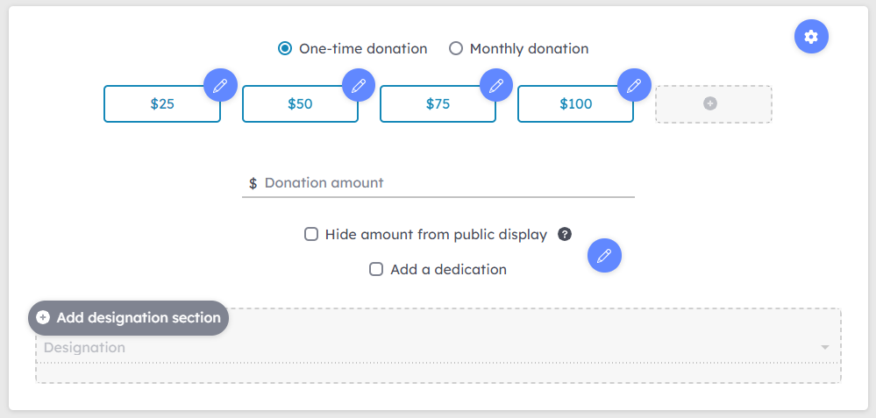

### Thank-you page

You can customize the page your donor sees after they complete their transaction. In this section, you can include a colorful thank you image, a letter from a client or leadership member, or even a video message! The character limit is 5000, but we recommend keeping it relatively brief and primarily visual. You can also include a button to direct them to your website or a newsletter sign-up. This next step helps deepen their engagement with you when they are thinking about your organization.

### Donation receipt

You can see a preview of donation receipts here and add a brief message that is included in the email acknowledgment that your donor receives. Again, you want to keep it short, but you can include links in this section if you want to direct them to learn more.

### Organization page planner

|  |
| --- |
| **Organization Page** |
| About (Max character count: 5000) |
| Images (Images should be jpg or png) |
| Video (Enter the URL of any YouTube, Vimeo, or Facebook video, including live streams) |
| Donation Levels (You can have as many as you like, but 4-5 is standard) |
| Thank-you page (Max character count: 5000) |

# Develop your Fundraising Plan

## Match

**It will help you raise funds during GiveBIG if you** create a matching fund to promote on your profile page and throughout your campaign. Matching funds are created by asking current and former board members, employees, volunteers, donors, and/or supportive companies to promise to match donations from GiveBIG donors up to a set level. For example, “Our board will match the first $3,000 in donations.” **Matching funds can be managed under *Fundraising tools* and *Matching Grants*** on your account.

### Why create a matching fund

Donors are more likely to donate to an organization that offers a match since it increases the impact of their giving. Double the Donation reports that 84% of donors say they are more likely to donate if a match is offered, and 1 in 3 people say they will give more money if a match is provided. Having a matching fund on your profile page says, “Our donors love us... get to know us, and you will love us too!”

Engaging your current supporters to provide a match also increases the impact of their gift. They get to create excitement for your cause and see their donation go further, too. It also gives them a sense of investment in the campaign’s success.

### How to use your matching fund

You can customize your matching fund beyond $1 for $1. You can also adjust the timing of your match and run multiple matches! Go to *Matching Grants* under the *Fundraising Tools* section of your *Dashboard* to see your options.

* + Want your match to go a little further? Set a minimum or maximum donation amount to match. You can also choose to match less than 100% of a donation.
  + Want to excite donors? Increase the amount their donation will be matched by setting the percentage to 150% or 200%. If you have a big match but don’t get many donors, this is a way to ensure your match gets achieved.
  + Want to make sure many donors get a chance to have their donations matched? Select apply match once per donor only to match the contributions of a donor (based on their email) once.
  + Trying to reach a specific goal? Set a cumulative threshold match so that the match only unlocks when you’ve hit a certain number of donors, donations, or donation total.

### How to create a matching fund

A match can be provided by one or more donors contributing to a pooled matching fund. Rather than wait and see if your most loyal donors contribute during GiveBIG, ask them to pledge a donation to your matching fund. Their donation not only supports your work, but it leverages additional contributions, making donating to a matching fund a smart decision for a donor! Your board and businesses that support you also make good candidates. For businesses, you can offer to highlight them on your page and promote them through your communications to donors.

### Matching fund planner

|  |  |  |  |
| --- | --- | --- | --- |
| **Matching Fund Donors** | **Giving History** | **Person Assigned to Ask** | **Outcome** |
| Board members |  |  |  |
| Major donors |  |  |  |
| Corporate partners |  |  |  |
| Volunteer groups |  |  |  |
| Committees |  |  |  |
|  |  |  |  |

## Peer-to-Peer Fundraising

### What is peer-to-peer fundraising?

**Peer-to-peer is a method of fundraising that involves your supporters raising money on your nonprofit’s behalf.** This type of fundraising is also known as social, personal, or P2P fundraising. If your message reaches more people, you will likely raise more money. In turn, when that message comes from someone a potential supporter cares about, they are more likely to donate. These new supporters can also reach out to their networks as well!

On the Washington Gives platform, this means empowering your supporters to create their fundraising pages to share on social media, email to friends and family, or post in work or community groups.

Fundraising pages are linked to your organization, so you automatically receive donations and contact information through your Washington Give account. **You can view and manage fundraising pages by going to *Fundraising Tools* under *Campaigns.***

You can help your fundraisers be successful by using our [Tools for Fundraisers](https://www.wagives.org/giving-events/givebig22/frtoolkit), including a toolkit that you can customize and send to your supporters. Once a fundraiser customizes and submits their fundraising page, you will be notified by email**. You can edit or make a page inactive under *Campaigns*** at any time should it be identified as unhelpful or inappropriate.

**What constitutes a network?** Family, friends, coworkers, fellow volunteers, customers, or clients… anyone the fundraiser regularly interacts with that they have a positive relationship with!

You can also create organizational fundraising pages. This is an optional feature that allows your organization to create fundraising pages under your organization’s name under *Campaigns*. It provides a mechanism to raise funds for a specific project or location. While these funds are still unrestricted, we ask that you consider donor intent when creating these pages. You cannot use this feature to create fundraising pages on behalf of an individual, as your organization will be listed as the fundraising page creator.

When a donation is made through a fundraising page, it will show up as part of your overall donation total and on your donation report. The donation report will indicate which fundraising page a donor gave through under *Campaign*.

### Who to ask to be a peer-to-peer fundraiser?

Start with your board. All board members should be expected to make a financial contribution to the organization they serve. By contributing to a matching fund pool or creating a fundraising page that they share with their network, they can use their commitment to your organization to inspire others to give. This is an opportunity for your entire board to rally around your mission and collect donations as ambassadors for your organization.

Other potential fundraisers are volunteers, clients, staff, fans on social media, or anyone who knows your organization and has a personal connection they can share to encourage their contacts to give!

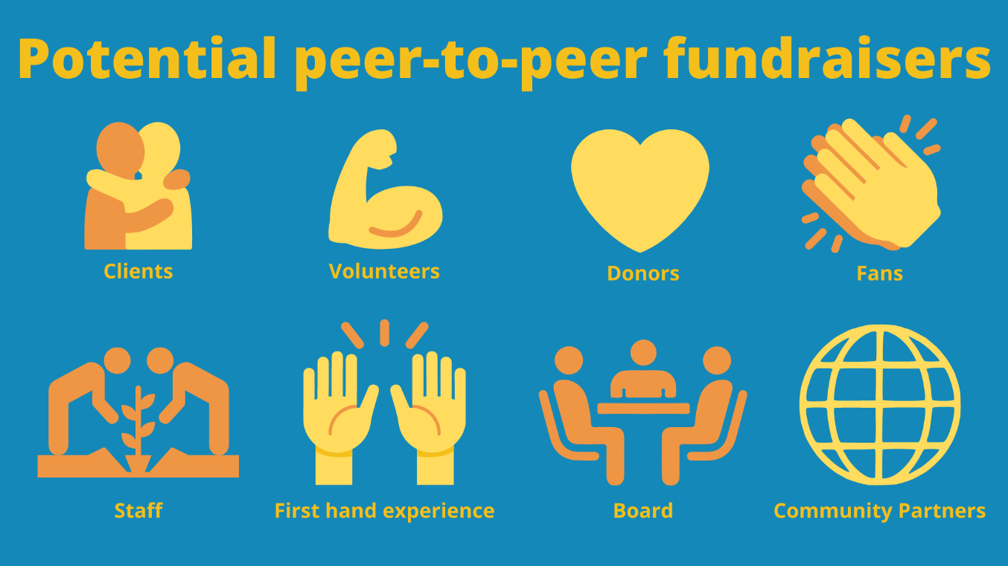

### Peer-to-peer fundraising planner

|  |  |
| --- | --- |
| **Potential Fundraiser** | **Contact Information** |
|  |  |
|  |  |
|  |  |
|  |  |
|  |  |

## Donor-Advised Funds and Individual Retirement Account Contributions

Some people with IRAs or DAFs simply make direct donations on the platform using a credit card or e-check. However, if they want the funds to be distributed from their IRA or donor-advised fund, we have made it easy to convey their intended donations to their financial advisor or DAF account to *send directly to your organization*. Once the advisor has confirmed intent to send a DAF/IRA contribution through Washington Gives, the intended donation will show up on your donation report and count towards your goal on your organization page.

Learn more about [Giving by DAF/IRA](https://www.givebigwa.org/DAF) through Washington Gives.

# Communication Plan

For a successful campaign, you need to plan who you will contact, when, and in what way. If you don’t ask people to give and make it clear why it’s important to give a gift, you won’t succeed.

Start with figuring out who you will contact (your audience), ways you will contact them (methods), and the messages you will send them.

## Audience

### Contact lists

Knowing your audience, or who you will ask to give, is your first step to creating a communication plan.

Assemble lists of people to ask to give along with their contact information. Ideas include:

* + Previous donors
  + People who attended your events but did not donate
  + Current and former board and staff members
  + Current and former volunteers
  + Vendors and local businesses you patronize
  + People at companies that have supported you
  + Clients or alumni, when appropriate

Be sure to include everyone who participated in GiveBIG in the past! Prior year donor lists can be accessed under the *Reports* section of the website. You can export contact lists sorted by time period, donation type, and campaign type.

### Contact list planner

|  |  |  |  |  |
| --- | --- | --- | --- | --- |
| **Audience** | **Estimated #** | **Confirmed # with email** | **2022 Target** | **2022 Actual** |
| Previous donors |  |  |  |  |
| Volunteers |  |  |  |  |
|  |  |  |  |  |
|  |  |  |  |  |
|  |  |  |  |  |

## Message

Now that you know who you are communicating to, you can create your message. A consistent and inspirational message that asks your audience to make a gift and be part of your mission is key to your success.

### Creating content

That it’s GiveBIG is not a strong enough message to encourage people to give. You need to make it clear why readers should take action. How can being part of your mission help them live their values? Does giving to you help accomplish something they care about?

#### Ideas to inspire:

* + Set a goal to expand a program or fund a project
  + Share client stories of success
  + Educate and engage your readers with eye-grabbing infographics and facts
  + Highlight volunteers, staff, and donors that make your organization thrive
  + Thank your prior donors, and show what your organization did with their donations
  + Communicate important milestones and feel-good moments

Don’t forget to get the GiveBIG logos and graphics toolkit on the [Tools for Nonprofits](https://www.wagives.org/giving-events/givebig22/nptoolkit) page!

### Content planner

|  |
| --- |
| **Key Messages** |
|  |
|  |
|  |

|  |
| --- |
| **Content Ideas** |
|  |
|  |
|  |

|  |
| --- |
| **Images** |
|  |
|  |
|  |

### Sample schedule

|  |  |
| --- | --- |
| **Date** | **Message** |
| April 19 | Early giving is open. Save the date for May 3-4! |
| April 27 | Reminder of early giving |
| May 2 | GiveBIG starts tomorrow! |
| May 3-4 | GiveBIG! |
| May 5 | Thank you to your donors, announcement of your total donations, and reminder they can still donate. |

### Sample emails

Below are sample emails for your campaign. Remember, when you are talking with people who know about GiveBIG, encourage them to engage their networks in addition to giving themselves.

#### April 26, 2022 – 1 Week Prior

Dear ____,

In one week, on May 3-4, thousands of people are going to show their support for their favorite Washington nonprofits during GiveBIG. On that day, your donation will help us achieve our mission to [agency specific message].

Show your support for our organization and mission, by telling your friends and colleagues about why you support us. [Consider including a story about a client, why a donor gave a gift, or what caused a volunteer to choose your particular cause.]

We need your help with these three things:

* Mark May 3-4 on your calendar or donate now!
* Follow us on [insert link to your Facebook account] and [insert link to your Twitter account] to help build our momentum by telling all your friends and family why you support our organization through #GiveBIG.
* Spread the word! Forward this email to your family and friends along with a personal note as to why you believe in our work, and why they should give on May 3-4.

We can’t wait to celebrate the difference your generosity will make when you GiveBIG on May 3-4!

#### May 2, 2022 – Day before GiveBIG

Tomorrow is the first of two BIG days of giving! Join thousands who are showing their support for their favorite nonprofits. Every donation will help us go further to achieve our mission to [agency specific message mission].

Here’s how you can help:

1. Give to [your organization] at [link to your GiveBIG profile].
2. Follow us on [insert link to your Facebook account] and [insert link to your Twitter account] to help build our momentum by telling all your friends and family why you support our organization through #GiveBIG.
3. Spread the word! Forward this email to your family and friends along with a personal note as to why you believe in our work, and why they should give today.

Tomorrow is your chance to make a real difference right here in your community. Thanks for your support!

### Sample social messages

#### One Month Prior – Send a Save the Date Message

Post now to let your followers know about GiveBIG, that your organization is participating, and ask them to mark the date on their calendar. Let them know that they have the option of going on to your Washington Gives page any time between April 19 through the event on May 3-4. They can also give year-round on the platform!

Potential Facebook/Twitter/Instagram posts:

* Let’s show everyone that our community is full of #generosity! On May 3-4, help us celebrate #GiveBIG by [agency specific message about mission]. [link to your Washington Gives page]
* Let the countdown begin! Mark your calendar for #GiveBIG on May 3-4. Invite your friends, co-workers, or that special someone in your life to join in our community-wide day to #giveback. [link to your Washington Gives page]

#### 3 Weeks Prior - Facebook Event

Create a Facebook event for May 3-4 and invite all your Facebook followers to the event.

Event Details:

* Event Name: GiveBIG to [your organization]
* Hosted by: [your organization] and GiveBIG
* Date: May 3-4, 2022 at 12:01 a.m. – 11:59 p.m.
* Location: [your address]
* Link: [link to your Washington Gives page]
* Description: [Some copy from your Washington Gives page description]
* Graphics: [add the GiveBIG logo to an image from your organization]

#### April 19, 2022 – GiveBIG Campaign Begins

When the GiveBIG campaign begins, post on social media to let your followers know they can help you reach your goals and spread the word about your campaign.

Sample Facebook/Twitter/Instagram posts:

* #giveback through [#GiveBIG](https://www.facebook.com/hashtag/givebig?epa=HASHTAG)! Donate early to [your organization] [link to Washington Gives page].
* Even the smallest donation can make a big #impact, so #GiveBIG on May 3-4 or make an early donation today! [link to your Washington Gives page]

#### May 3, 2022 – GiveBIG event starts tomorrow!

Post on May 3 asking supporters to give now, so they don’t miss GiveBIG.

Sample Facebook/Twitter/Instagram posts:

* #GiveBIG today so you don’t forget tomorrow! [agency specific message about mission] [link to your Washington Gives page]
* Did you know you can donate before tomorrow’s #GiveBIG? Help us reach our goal by donating to [your organization] [link to your Washington Gives page]

#### May 3-4, 2022 – GiveBIG is today!

Post at least two messages during the day to remind people that it is GiveBIG. Give them updates and encourage them to join with others in supporting your organization.

Potential Facebook/Twitter/Instagram posts:

* Calling all #changemakers – Can you help us reach our goal of $____? [link to your Washington Gives page]
* Even a small donation would help us reach our goal. Your #donation will help us [list out goals in as much detail as possible] when you #GiveBIG TODAY. [link to your Washington Gives page]
* What did you do today to #change the world? Make it happen when you #GiveBIG TODAY at [link to your Washington Gives page]
* It is #GiveBIG today, and we’ve secured well above half of our #fundraising goal! Thank you to everyone who has donated so far, and if you haven’t donated yet, make it happen at [link to your Washington Gives page]

It’s the final hour for #GiveBIG! Have you donated to us during #GiveBIG? Make sure to let your friends know how you #givewhereyoulive! [link to your Washington Gives page]

## Methods

You can build out new communication methods, but it’s generally easier and more effective to reach out in the ways your supporters are used to. Read below for tips on common communication methods.

### Emails and direct mail

Email and mail are the most effective methods of communication for fundraising outside of asking someone face-to-face. While social media is easier to do, a specific ask is more likely to convert readers to donors.

If you do not have one, set up an account with an email marketing services platform like Constant Contact or Mailchimp. These tools make it easy to create professional emails and customizeable emails. Develop a schedule for sending out 4-6 emails to your donors and supporters. Your message should go beyond a countdown to GiveBIG, but that countdown can help time your communications.

Check that your email and mail link where a reader can make their donation. For direct mail, you may consider an URL shortener like [Bit.ly](https://bit.ly/) to make a shorter link to put on your postcard or letter.

### Social media

Post frequent updates to your social media platforms and your organization’s website. Report on and thank your donors for their generosity and involvement in your social media posts. Facebook, Twitter, and Instagram are the most used platforms, but where ever your donors and potential supporters are is where you should be active. Make sure to include the link to your organization page!

#### Washington Gives social media

Stay in the loop about GiveBIG and the Washington Gives platform by following us on social media. Help us grow these channels by liking and sharing posts. The more buzz we get about the event, the more new donors we can all reach. Make sure to tag us (@wagives), and we will share your posts too!

* Facebook: <https://www.facebook.com/WAGives/>
* Twitter: <https://twitter.com/wagives>
* Instagram: <https://www.instagram.com/wagives/>

#### Hashtags

Hashtags are a way to categorize content on social media and make it easy for users to search for content. You can use hashtags in your social media posts by placing the number sign (#) in front of a word or unspaced phrase in a message. It is best to use hashtags sparingly but deliberately. Social media engagement decreases after more than two hashtags are used. **The primary hashtag for GiveBIG is #GiveBIG.**

If your organization frequently uses particular hashtags to highlight your mission, we suggest using them in your GiveBIG posts to remind donors of your cause. Not sure which hashtags to use? You can use this [hashtag generator](https://www.all-hashtag.com/hashtag-generator.php) or this [hashtag analyzer](https://www.all-hashtag.com/hashtag-analytics.php) to determine the popularity and ranking of a hashtag. Here are some suggested hashtags for GiveBIG that you can choose in addition to #GiveBIG: **#GiveWhereYouLive**, and **#TogetherWeGiveBIG**.

### Website

Engage with your organization’s website visitors by including a GiveBIG save-the-date graphic on your home page that links to your Washington Gives page and invites viewers to give. If you have a blog, post a message, including a link to your page.

### Newsletters

Include GiveBIG save-the-date messages in all print and electronic newsletters and communications. Encourage your readers to reach out to their friends, family, and colleagues and ask them to support your organization.

### Email signatures

Develop a signature line for your staff and board members to promote giving during early giving and giving day. Watch this [short video](https://support.office.com/en-us/article/video-create-an-email-signature-31fb24f9-e698-4789-b92a-f0e777f774ca) on how to create a customized signature in Outlook.

# VI. Stewardship Plan – Thanking Donors

Regardless of your GiveBIG campaign outcome, you must follow up with your donors, fundraisers, and partners to show your appreciation. Donors on the Washington Gives website will receive an email confirmation that serves as their tax receipt. You can resend a receipt from the *Donations* report page by clicking on the three dots next to the supporter’s donation and selecting *Resend Receipt.*

Even though donors receive a receipt and thank you message on the platform (you can customize this under Checkout and Thank-you Page on your Dashboard), you should also send them a personal thank you email or letter and/or call them. You can also post messages through the communication channels you used to promote GiveBIG to announce your final total and show your thankfulness and appreciation for your donors and fundraisers.

## Social Media Thank You

Consider posting a photo or video of your organization’s leaders, board, staff, or clients thanking donors along with the below message.

|  |
| --- |
| **Sample:**  Thank you to all donors who joined us for GiveBIG and gave on May 3-4 to support [your organization]! Your support will [organization-specific message about mission]. Thank you for sharing your love for your community and supporting your cause! #GiveBIG |

## Mailed Thank You

|  |
| --- |
| **Sample:**  Dear ________, Thank you for joining us for GiveBIG and donating $_____ on ____. Over _______ donors came together to raise $________! These funds will [organization-specific message about mission]. We are so lucky that you support our passion, mission, and organization. Thank you for being a committed, enthusiastic, and supportive partner in our work. [Add more information on your upcoming programs, your recent successes, and the impact of your work.]  With gratitude,  (Executive director, board member, etc.) |

## Thank You Calls

You can up the ante for new, long-time, or major donors by having an organizational leader or board member call them. Volunteers, program staff members, and clients can also be potential callers. A call creates a personal connection that can boost donor engagement and loyalty to your organization.

|  |
| --- |
| **Sample:**  Hello [donor name] this is [caller name] from [organization]. I’m calling to thank you for your outstanding support of [your organization] through GiveBIG this year! Your generous support makes our work [*describe your work*] possible.  [You can have the caller invite them to an event, share a piece of relevant news about your organization, or ask the donor about why they gave. If they ask the donor to share why the cause matters to them, they must document what the donor says. This can be valuable information into how you can improve your fundraising and communications.] |

## Next Steps

Whether a donor gave a small or large gift, you should plan on your next step to deepen and maintain your connection with each giver. When and how will you connect with your supporters next? The next time you contact them shouldn’t be for next year’s GiveBIG.

**Ideas for next steps:**

* + Invite them to an event or call to action.
  + Ask them to sign up for your mailing list or follow you on social media.
  + Send them updates about what your organization has done with the funds you received through GiveBIG
  + Invite them to join you again for GivingTuesday, this time as a fundraiser.